1. Write a C program to find the Area of a triangle.

#include<stdio.h>

int main()

{

float base,height;

float area;

printf("enter base and height\n");

scanf("%f%f",&base,&height);

area= (base*height)/2;

printf("\nArea of trianle is:%.2f\n\n\n\n",area);

}

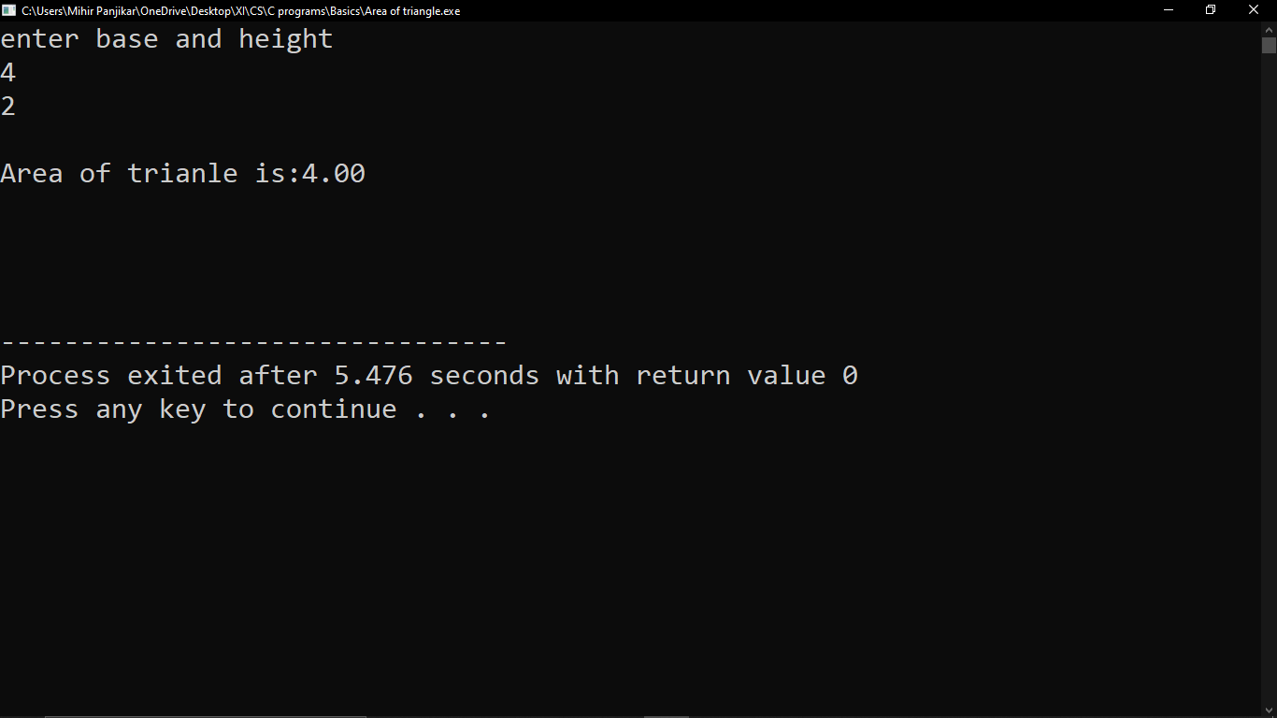

1. Write a C program to interchange two values without using a third variable.

#include<stdio.h>

int main()

{

float N1,N2;

printf("Enter values for N1\n");

scanf("%f",&N1);

printf("Enter values for N2\n");

scanf("%f",&N2);

printf("\nN1=%.2f,N2=%.2f \n",N1,N2);

N1=N1+N2;

N2=N1-N2;

N1=N1-N2;

printf("\nafter swapping \n\nN1=%.2f,N2=%.2f\n\n",N1,N2);

}

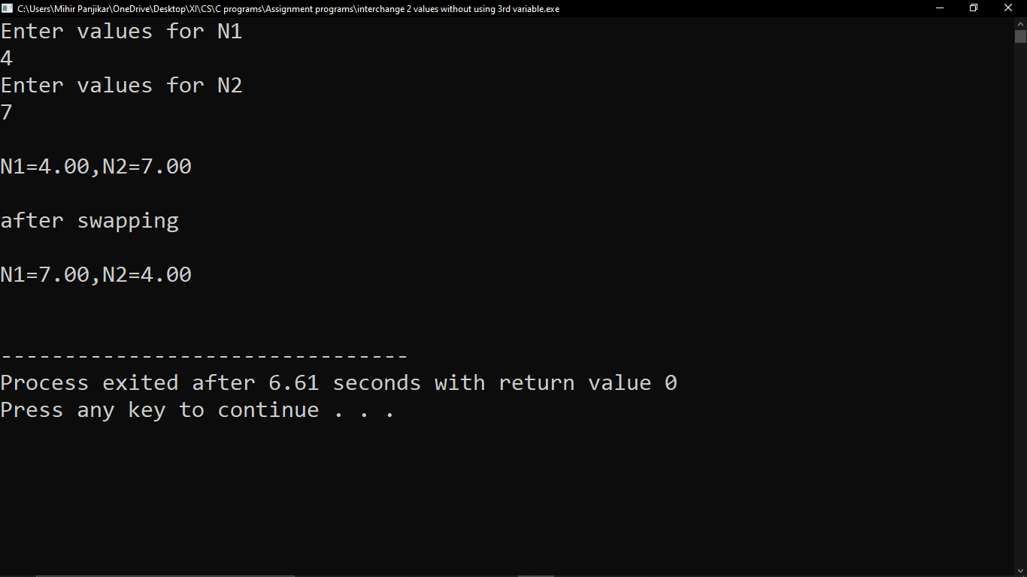

1. Write a C program to convert Centigrade to Fahrenheit.

#include<stdio.h>

int main()

{

float cel,fah;

printf("Enter degree celsius: ");

scanf("%f",&cel);

fah=(1.8)*(cel)+32;

printf("Degree fahrenheit: %.2f",fah);

}

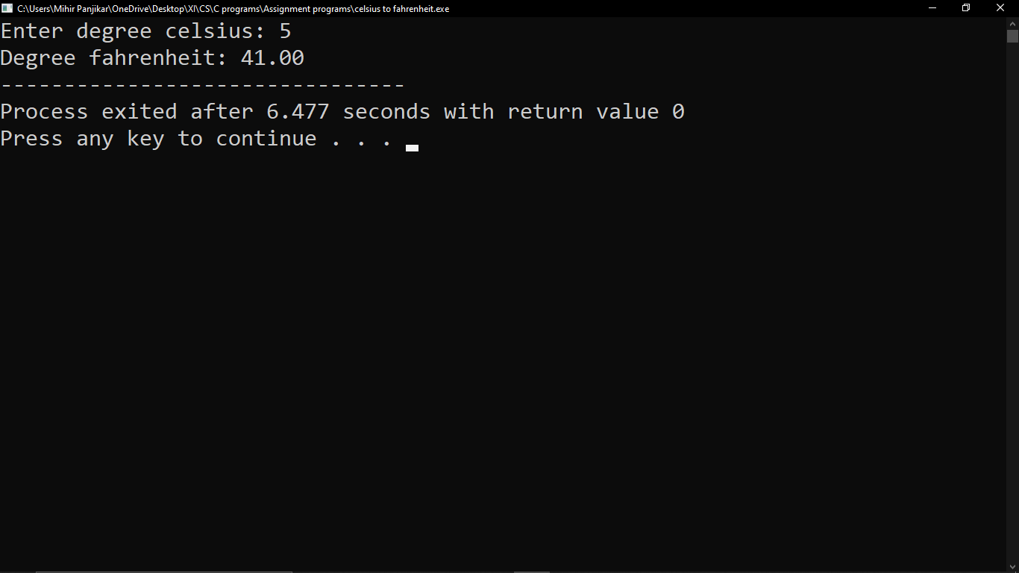

1. Write a C program to solve simultaneous equations.

#include<stdio.h>

int main()

{

double a,b,c,p,q,r,x,y;

printf("Enter the coefficents of the first equation of the form ax+by=c\n");

scanf("%lf%lf%lf",&a,&b,&c);//The coefficents of the first equation

printf("Enter the coefficents of the second equation of the form px+qy=r\n");

scanf("%lf%lf%lf",&p,&q,&r);//The coefficents of the second equation

if(((a*q-p*b)!=0)&&((b*p-q*a)!=0))

{

//In this case we have a unique solution and display x and y

printf("The solution to the equations is unique\n");

x=(c*q-r*b)/(a*q-p*b);

y=(c*p-r*a)/(b*p-q*a);

printf("The value of x=%lf\n",x);

printf("The value of y=%lf\n",y);

}

else

if(((a*q-p*b)==0)&&((b*p-q*a)==0)&&((c*q-r*b)==0)&&((c*p-r*a)==0))//In such condition we can have infinitely many solutions to the equation.

{

//When we have such a condition than mathematically we can choose any one unknown as free and other unknown can be calculated using the free variables's value.

//So we choose x as free variable and then get y

printf("Infinitely many solutions are possible\n");

printf("The value of x can be varied and y can be calculated according to x's value using relation\n");

printf("y=%lf+(%lf)x",(c/b),(-1*a/b));

}

else

if(((a*q-p*b)==0)&&((b*p-q*a)==0)&&((c*q-r*b)!=0)&&((c*p-r*a)!=0))//In such condition no solutions are possible.

printf("No solutions are possible\n");

}

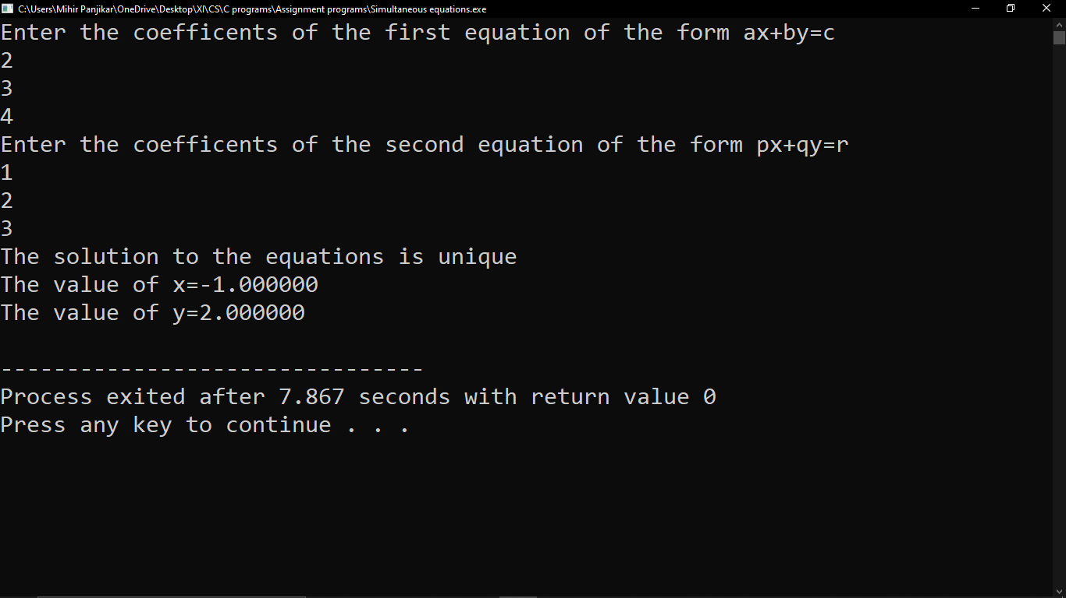

1. Write a C program to determine the largest of three numbers using if statement.

#include<stdio.h>

int main()

{

float n1,n2,n3;

printf("Enter the 3 numbers\n");

scanf("%f%f%f",&n1,&n2,&n3);

if(n1>n2 && n1>n3)

{

printf("\n%.2f is the largest number",n1);

}

if(n2>n1 && n1>n3)

{

printf("\n%.2f is the largest number",n2);

}

if(n3>n1 && n3>n2)

{

printf("\n%.2f is the largest number",n3);

}

}

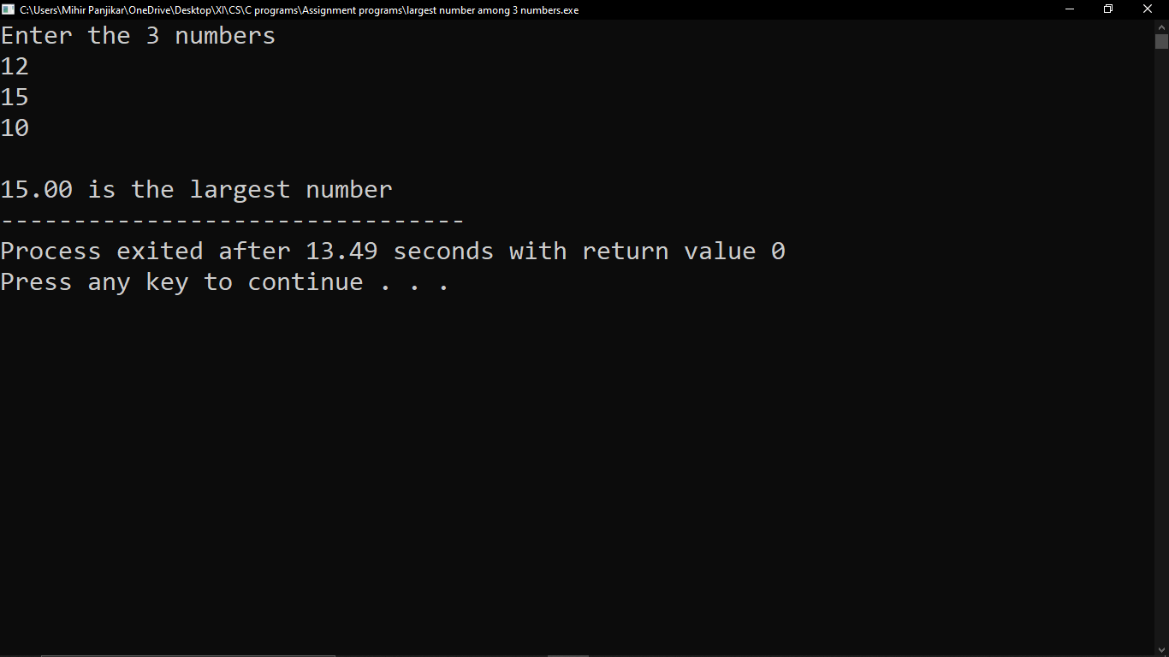

1. Write a C program to determine the roots of a quadratic equation using different conditions.

#include <stdio.h>

#include <math.h>

int main()

{

int a, b, c, d;

double root1, root2;

printf("Enter a, b and c where a*x*x2 + b*x + c = 0\n");

scanf("%d%d%d", &a, &b, &c);

d = b*b - 4*a*c;

if (d < 0) { // complex roots, i is for iota (v-1, square root of -1)

printf("First root = %.2lf + i%.2lf\n", -b/(double)(2*a), sqrt(-d)/(2*a));

printf("Second root = %.2lf - i%.2lf\n", -b/(double)(2*a), sqrt(-d)/(2*a));

}

else { // real roots

root1 = (-b + sqrt(d))/(2*a);

root2 = (-b - sqrt(d))/(2*a);

printf("First root = %.2lf\n", root1);

printf("Second root = %.2lf\n", root2);

}

return 0;

}

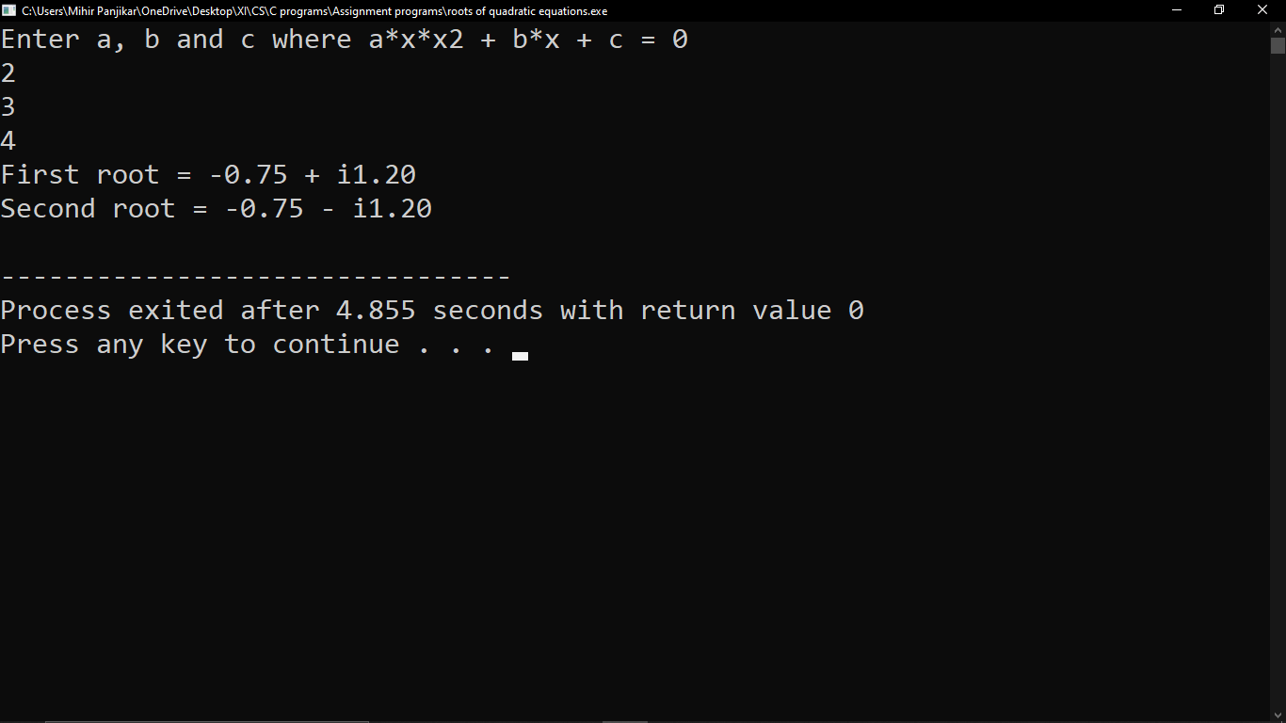

1. Write a C program to determine the class of a student when marks in 6 subjects are given.

#include<stdio.h>

int main()

{

Float M1,M2,M3,M4,M5,M6,per,outof,marks_obt;//marks obtained in subjects and total marks

printf("Enter marks obtained in 6 subjects\n");

scanf("%f%f%f%f%f%f",&M1,&M2,&M3,&M4,&M5,&M6);

printf("\nEnter Total marks\n");

scanf("%f",&outof);

marks_obt=M1+M2+M3+M4+M5+M6;

per=(marks_obt/outof)*100;

printf("\nThe percentage of the student is %.2f%%\n",per);

if(per>=60)

{

printf("\nThe student has passed with First Division.\n\n");

}

else if(per>=50&&per<=59)

{

printf("\nThe student has passed with Second Division.\n\n");

}

else if(per>=40&&per<=49)

{

printf("\nThe student has passed with Third Division.\n\n");

}

else if(per<40)

{

printf("\nThe student has Failed.\n\n");

}

}

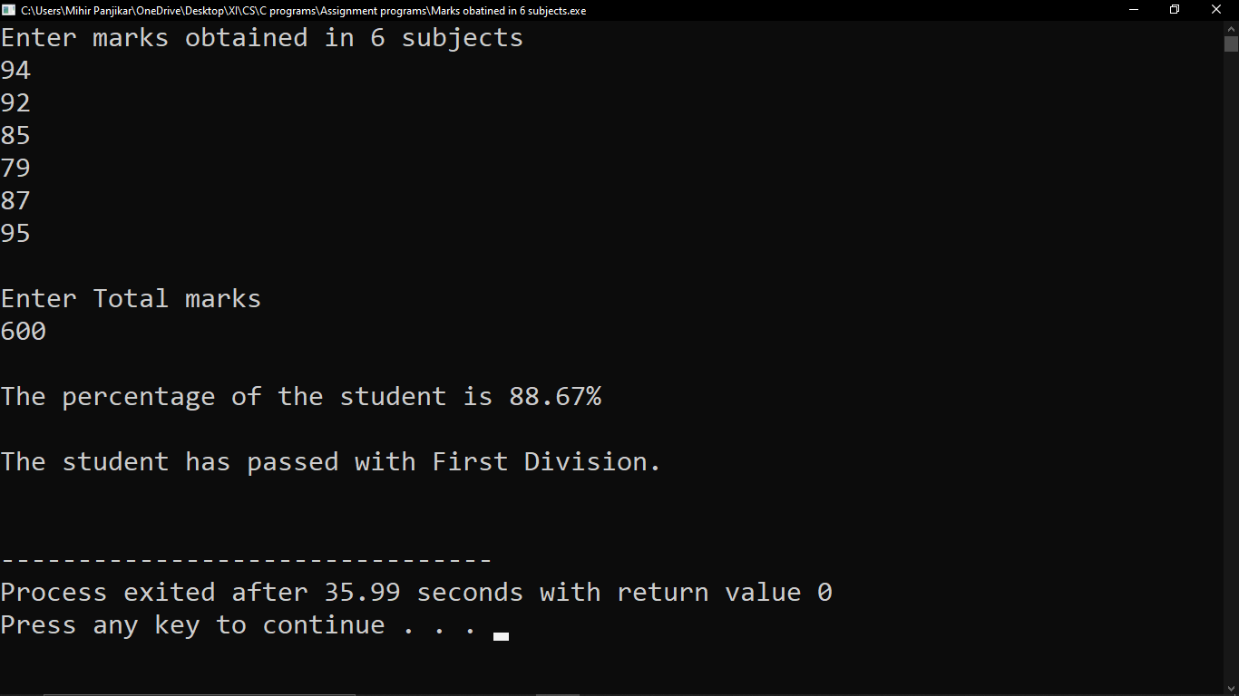

1. Write a C program to determine the sum of the digit of a number using While loop.

#include <stdio.h>

int main()

{

   int n, t, sum = 0, remainder;

printf("Enter an integer\n");  
   scanf("%d", &n);

t = n;

while (t != 0)  
   {  
      remainder = t % 10;  
      sum       = sum + remainder;  
      t         = t / 10;  
   }

printf("Sum of digits of %d = %d\n", n, sum);

return 0;  
}

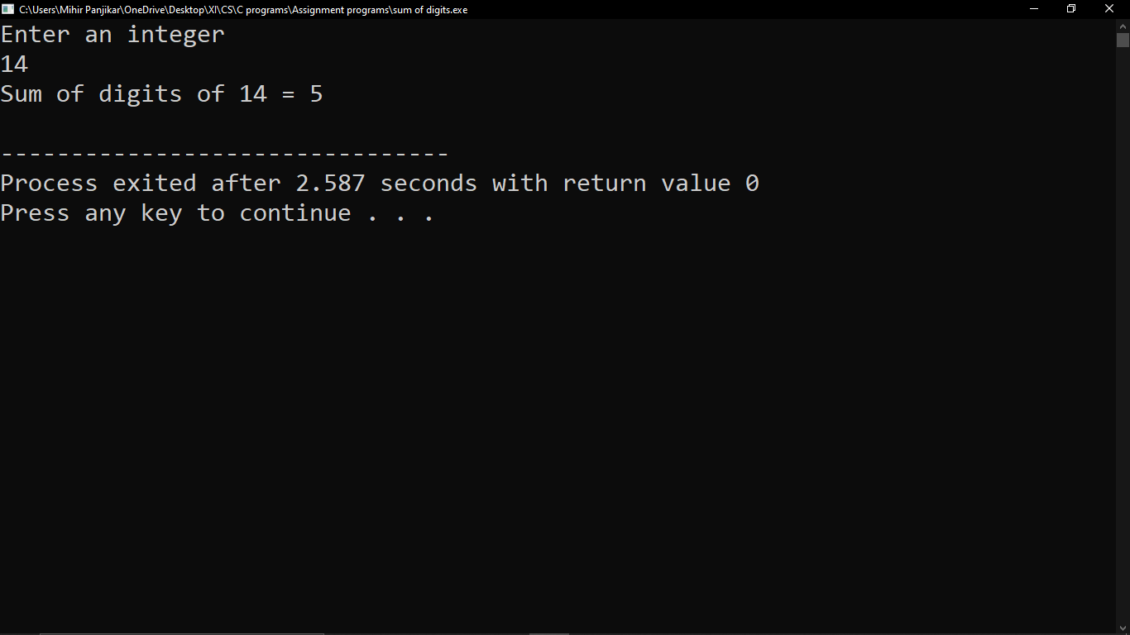

1. Write a C program to generate the Fibonacci Series using the While loop.

#include<stdio.h>

int main()

{

int num,i=0,t1=0,t2=1,t3;

printf("Enter number of terms\n");

scanf("%d",&num);

while(i<num)

{

printf("%d",t1);

t3=t1+t2;

t1=t2;

t2=t3;

i++;

}

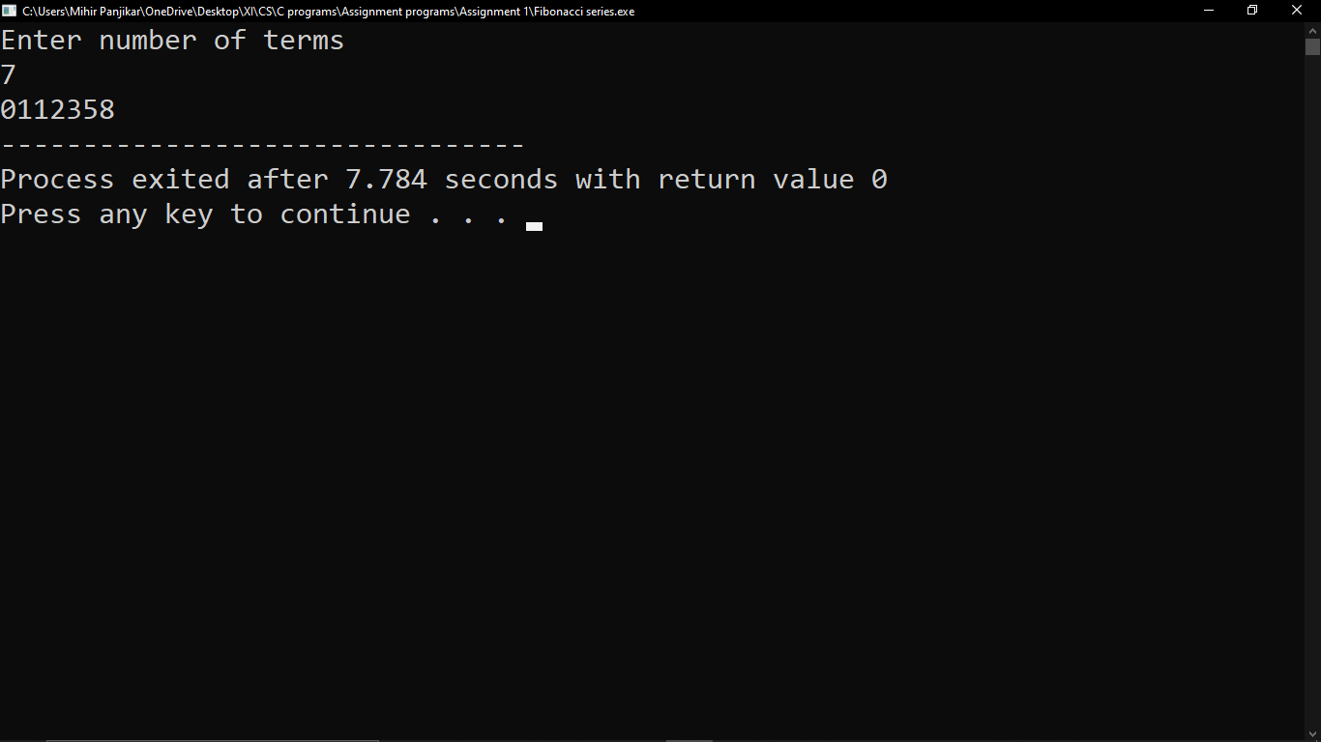}

1. Write a C program to determine the Reversal of a number using Do.... While loop.

#include <stdio.h>

int main()

{

int n, reverse_Number = 0, rem,Original_number=0;

printf("Enter a number to get reverse number\n");

scanf("%d", &n);

Original_number=n;

do

{

rem = n%10;

reverse_Number = reverse_Number*10 + rem;

n /= 10;

}

while(n != 0);

printf("Reversed Number of %d is = %d",Original_number,reverse_Number);

